Set 8. Quantitative relationship between wavelength, frequency, energy, and light

Skill 8.01: Understand the relationship between wavelength, frequency and light “color”
Skill 8.02: Calculate the wavelength, given the frequency and vice versa
Skill 8.03: Understand the relationship between energy, wavelength, and frequency
Skill 8.04: Calculate the energy of light given the frequency or wavelength
Skill 8.05: Describe Bohr’s theory of the hydrogen atom and how it accounts for line spectra
Skill 8.06: Calculate the Energy, Wavelength, Frequency, and Color of light that results when a photon is emitted from the hydrogen atom
Skill 8.07: Describe the effect of nuclear charge on the energy an atom emits

Skill 8.01: Understand the relationship between wavelength, frequency, and light color

From fireworks to stars, the color of light is useful in finding out what’s in matter. The emission of light by hydrogen and other atoms has played a key role in understanding the electronic structure of atoms. Trace materials, such as evidence from a crime scene, lead in paint or mercury in drinking water can be identified by heating or burning the materials and examining the color(s) of light given off in the form of bright-line spectra.
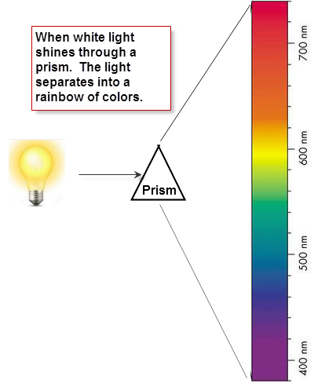
Skill 8.01. Problem 1
Refer to the figure shown to the right. Identify the range of wavelengths associated with each color. The “Reds” have already been filled in.
Color Range | Wavelengths
Reds | 680–740
Oranges

Yellows

Greens

Blues

Violets

Light consists of electromagnetic waves. Electromagnetic waves are characterized by their wavelength and frequency:

- The wavelength, λ (lambda) is the distance between identical points on successive waves.
- The frequency, ν (nu), is the number of waves that pass through a particular point in one second.
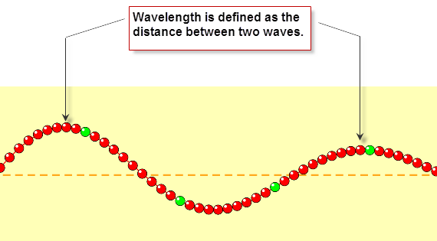

Skill 8.01 Problem 2
Navigate to the wave on a string simulator.

http://phet.colorado.edu/sims/html/wave-on-a-string/latest/wave-on-a-string_en.html

Once there, select the “No end” option and the “Oscillate” option
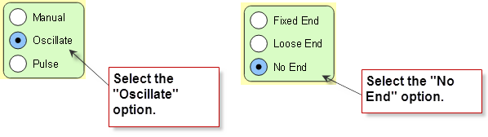

- Locate the frequency slider. Move it back and forth and observe how the wavelength changes.

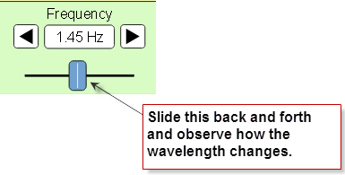
- When you increase the frequency, what happens to the wavelength? Does it increase or decrease?

- When you decrease the frequency, what happens to the wavelength? Does it increase or decrease?

- What is the relationship between frequency and wavelength? Is it inverse or direct?

- Refer to the colors below. Sort the colors from low to high with respect to frequency.

Color Range | Order of frequency (1 = lowest)
Reds

Oranges

Yellows

Greens

Blues

Violets

Skill 8.02: Calculate the wavelength, given the frequency and vice versa

All electromagnetic waves travel at the same speed (3.00 x 10⁸ m/s). This speed is referred to as the speed of light. By the convention, the symbol, c, is used for the speed of electromagnetic radiation. The speed, c, of an electromagnetic wave is the product of its wavelength and frequency,

c = λ ν = 3.00 x 10⁸ m/s

Skill 8.02 Problem 1
For each of the colors below,
- Indicate the average wavelength in nanometers (nm)
- Convert each wavelength to nanometers (1 x 10⁻⁹ m = 1 nm)
- Calculate the frequency

Color Range | Average λ (nm) | λ (m) | ν (/s)
Reds | 710 nm | 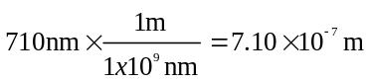 | 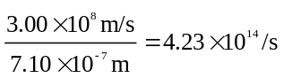
Oranges

Yellows

Greens

Blues

Violets

  - Are the wavelengths of ultra-violet light longer or shorter than that of visible light?

  - Are the frequencies of ultra-violet light longer or shorter than that of visible light?

  - Are the wavelengths of infra-red light longer or shorter than that of visible light?

  - Are the frequencies of infra-red light longer or shorter than that of visible light?



Skill 8.03: Understand the relationship between energy, wavelength, and frequency

Skill 8.03 Problem 1
- Now return to the simulator (http://phet.colorado.edu/sims/html/wave-on-a-string/latest/wave-on-a-string_en.html) Select the “Manual” option.

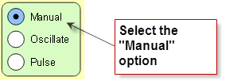
Move the wrench up and down as fast as you can and observe the wavelength. Now move the wrench up and down slowly and observe the wavelength.

- When you moved the wrench up and down quickly (high energy), what happened to the wavelength? Did it increase or decrease?

  - When you moved the wrench up and down slowly (low energy), what happened to the wavelength? Did it increase or decrease?

- What is the relationship between energy and wavelength? Is it inverse or direct?

- Refer to the colors below. Sort the colors from low to high with respect to energy.

Color Range | Order of energy (1 = lowest)
Reds

Oranges

Yellows

Greens

Blues

Violets

Skill 8.04: Calculate the energy of light given the frequency or wavelength

Max Planck and Albert Einstein showed that light could be viewed as a stream of particles or photons, or a particle. This concept is illustrated below,

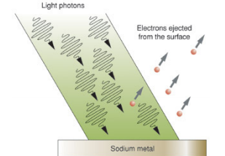

The picture above shows that when a metal receives sufficient energy (packet), electrons can be ejected as packets of energy. The packets of energy absorbed by the metal are referred to as photons.

The energy of a single photon (or packet of energy) in joules (J) is given by:

E = hν

Where, h, is called Planck’s constant and is equal to 6.63 x 10⁻³⁴ J.s and v is the frequency of the radiation.

Skill 8.04 Problem 1
Refer to problem 8.02 Problem 1
- For each color, copy the corresponding frequency
- Calculate the energy in joules

Color Range | frequency ν | Energy (J)
Reds | 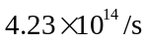 | 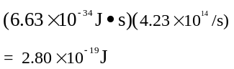
Oranges

Yellows

Greens

Blues

Violets

- How do the energies of ultra-violet compare to visible light?

- How do the energies of infra-red light compare to visible light?

Skill 8.05: Describe Bohr’s theory of the hydrogen atom and how it accounts for line spectra

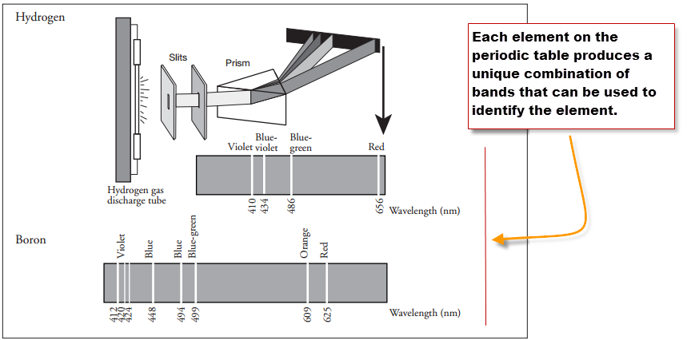
Experiments showed that the light emitted from individual elements did not produce the rainbow observed by the separation of white light.
Instead, when the light from individual elements were separated with a prism, only light of specific wavelengths appeared.

Notice in the picture to the left, when the light from hydrogen is separated with a prism only 4 light bands appear. When the light from boron is separated with a prism, 8 bands of light appear.

Skill 8.05 Problem 1
Refer to the diagram below to complete the following
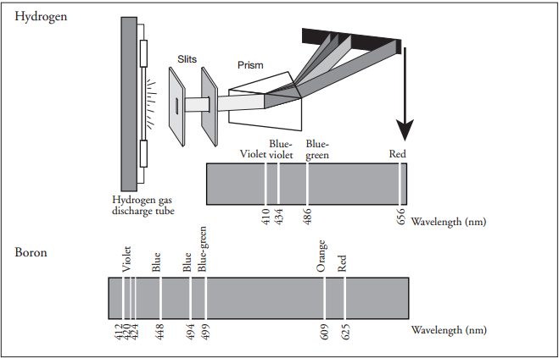
(a) Use colored pencils to color the hydrogen and boron spectral lines within their respective spectra.

(b) List the spectral lines for hydrogen gas by color and corresponding wavelength. Sort the colors from low to high with respect to energy.

Color | Wavelength | Order of energy (1 = lowest)

To account for the line spectra produced by elements, Bohr proposed that electrons could only be located in certain orbits. Since each orbit has a particular energy associated with it, the energies associated with an electron is fixed (or quantized). Bohr suggested that when the electron absorbs a photon of energy it jumps to a higher energy level. When the electron drops to a lower energy level, it releases a photon of energy in the form of light as shown in the figure below.

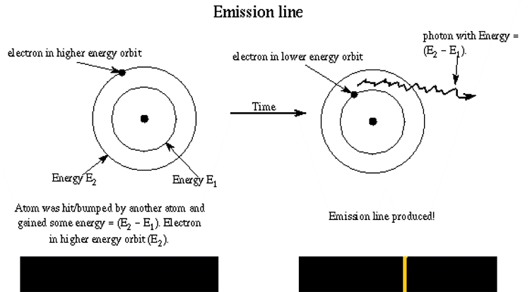
Skill 8.05 Problem 2
Navigate to the following link,

https://sites.google.com/a/boiseschools.org/bohratom/

Navigate through the tutorial then complete the following questions.
- Is energy absorbed or released for the electron transition shown in the diagram to the right? How do you know? | 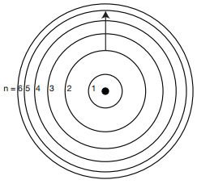
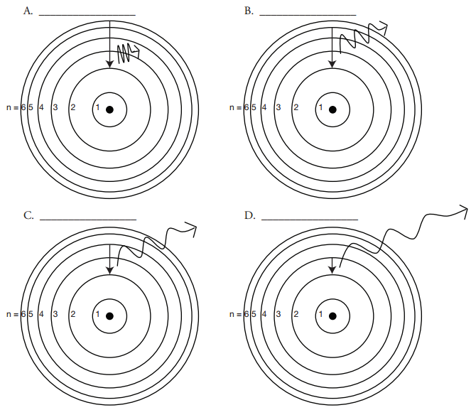
- The diagram above shows the allowed transitions in the hydrogen atom.

- For the transitions shown, is light being absorbed or emitted? How do you know?

- Complete the following table. Refer to the spectrum you colored in “Skill 8.02 Problem 1” to identify the color of emitted for each transition.
Picture | Transition | Color of light | Order of energy (1 = lowest)
A | n= to n=
B | n= ___ to n= ____
C | n= ___ to n= ____
D | n= ___ to n= ____

- What is the relationship between the transition and energy of light emitted? In other words, as the length of the transition increases, does the energy that is emitted increase or decrease?

Skill 8.06: Calculate the Energy, Wavelength, Frequency, and Color of light that results when a photon is emitted from the hydrogen atom

The Energy is released as electrons fall from excited states to ground states. If the states are known, then the energy of the light emitted can be calculated as follows,

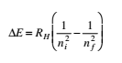
Where R_{H}, the Rydberg constant, has the value 2.18 x 10⁻¹⁸ J. The number n is an integer called the principal quantum number; it has the values n = 1, 2, 3, .... The principal quantum represents the energy
level where the electron can exist. n=1 corresponds to the most stable state, and is also referred to as the
ground state. As n increases, the stability of the electron decreases. Levels about n=1 are referred to as excited states.

Because electron transitions result in the emission (or absorption) of a photon of light with a frequency v we can write,
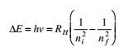
When a photon is emitted, n_{i} > n_{f} and E is negative because energy is lost. When a photon is absorbed, n_{i}<n_{f}
and E is positive because energy is absorbed. Each spectral line in the emission spectrum corresponds to a particular transition in the hydrogen atom.

Skill 8.06 Problem 1
- For each of the transitions you identified in Skill 8.05 Problem 2, calculate the associated energy, frequency, and wavelength

- Complete the following table for each transition
 | Transition | E(joules) | v (/s) | λ  (m) | λ  (nm)
A | n_{i}= 6 to n_{f} = 2 | 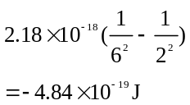 | 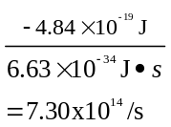 | 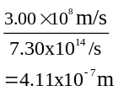 | 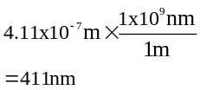
B | n_{i}= to n_{f}=
C | n_{i}= to n_{f}=
D | n_{i}= to n_{f} =___

- For each of the transitions, is light being absorbed or emitted? How do you know?

- Indicate whether each transition is exothermic (energy given off) or endothermic (energy absorbed). How do you know?

Skill 8.07: Describe the effect of nuclear charge on the energy an atom emits

Up until now we have only been concerned with transitions that produce energies that are visible to us. But there are other types of energies that are produced that we cannot see. The diagram shows the various energies that can be produced as electrons undergo transitions in an atom. Notice that we can only see a small sliver of this energy.

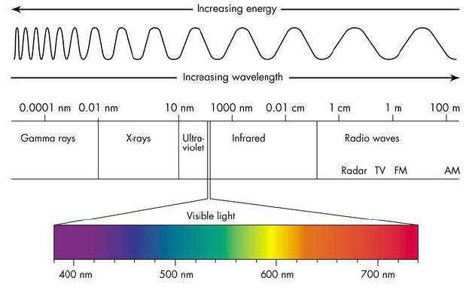
Skill 8.07 Problem 1
Refer to the diagram above then rank the following from low to high with respect to energy.
Energy | Order of energy (1 = lowest)
Gamma rays
X-rays
Radio waves
Visible light
Ultra-violet
Infrared

Skill 8.07 Problem 2
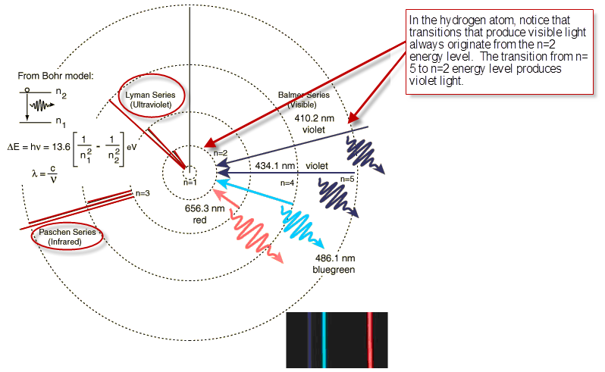
- The diagram above shows transitions that result in Infrared energy, Ultra Violet energy, and Visible energy. Notice that visible always originates from the n=2 energy level. From which energy level does.

- Infrared energy originate?

- Ultraviolet energy originate?

- Complete the follow table. Rank each energy according to the energy level from which the electron originated. Rank each from high to low with respect to energy.

Energy | Distance from the nucleus (1 = closest) | Order of energy (1 = lowest)
Ultra violet
Infrared
Visible

- What is the relationship between the distance from which an electron originates and its energy. In other words, do electrons that originate closer to nucleus have higher or lower energy than electrons that originate farther from the nucleus? Write a sentence that describes this relationship.

As you previously learned, atoms have protons and electrons. And because protons have a positive charge and electrons have a negative charge, it follows that they are attracted to one another. Binding energy, is the energy required to remove an electron from an atom.

Skill 8.07 Problem 3
The graph below shows the relationship between the mass number of an atom and the binding energy.
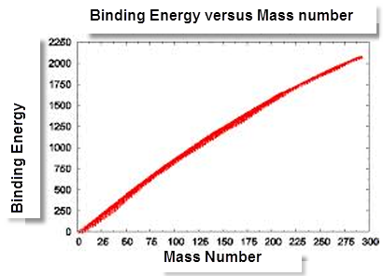
  - According to the graph, is the relationship between binding energy inverse or direct? In other words as the mass number increases does the binding energy increase or decrease?

  - Is the relationship between the number of protons in an atom and the binding energy inverse or direct?

  - Consider the following atoms, rank the atoms from low to high with respect to binding energy: H, He⁺, Ne²⁺

  - Now consider the following transition.

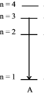
Complete the table to show how the energy released compares between different atoms.
Atom | Order of energy (1 = lowest)
He⁺
Li²⁺
H
Be³⁺

Set 8.0 Practice Problems

  - What is the wavelength (in meters) of an electromagnetic wave whose frequency is 3.64 x 10⁷ Hz?

  - (a) What is the frequency of light having a wavelength of 456 nm? (b) What is the wavelength (in nanometers) of radiation having a frequency of 2.45 x 10⁹ Hz?

  - Calculate the energy (in joules) of (a) a photon with a wavelength of 5.00 x 10⁴ nm and (b) a photon with a wavelength of 5.00 x 10-2 nm.

  - The energy of a photon is 5.87 x 10⁻²⁰ J. What is the wavelength (in nanometers)?

  - What is the wavelength (in nanometers) of a photon emitted during a transition from ni = 6 to nf = 4 state in the H atom?

  - Calculate the frequency (Hz) and wavelength (nm) of the emitted photon when an electron drops from the n=4 to the n=2 level in a hydrogen atom.

  - An electron in the hydrogen atom makes a transition from an energy state of principal quantum number ni to n = 2 state. If the photon emitted has a wavelength of 434 nm, what is the value of ni?

  - Answer the following questions regarding light and its interactions with molecules, atoms, and ions.1

- The longest wavelength of light with enough energy to break the Cl-Cl bond in Cl₂(g) is 495 nm.

- Calculate the frequency, in s⁻¹, of the light

- Calculate the energy, in J, of a photon of the light.

- Calculate the minimum energy, in kJ/mol, of the Cl-Cl bond

- A certain line in the spectrum of atomic hydrogen is associated with the electronic transition in the H atom from the sixth energy level (n=6) to the second energy level (n=2).

- Indicate whether the H atom emits energy of whether it absorbs energy during the transition. Justify your answer.

- Calculate the wavelength, in nm, of the radiation associated with the spectral line.

- Account for the observation that the amount of energy associated with the same electronic transition (n=6 to n=2) in the He⁺ ion is greater than that associated with the corresponding transition in the H atom.

